Labs Proposal: Ontos
Ontos is a Databricks App extending Unity Catalog with important business functionality, including data products & contracts, business glossaries, compliance checks, and more. While we are adding some rudimentary features to our platform now (that is, Databricks One, Discover Page, Governance Hub, Certification, Domains, Metrics), they are not sufficient for enterprise users to model their business efficiently. Ontos adds an ontology (where “ontos” is the root of word “ontology”) based approach that connects domains, products, glossaries in a hierarchical, semantic way. It also adds functionality for supporting governance roles, such as asset management for data stewards, or persona management for data security officers.
Full pitch deck: Ontos Pitch Deck
Owners | Ontos Pitch DeckLars GeorgeJoshua Green |  | Status | Design sketch
Product (team) | TBD |  | Artifact | Databricks App
Repository name | https://github.com/larsgeorge/ucsak-app |  | Language | Python
Target release | Nov 1, 2025 |  | Go link | go/ontos

Review status 2
Part 1: Request for comments 2
Customer evidence 2
Markitecture 2
Graduation strategy 3
Project kickoff 3
Administrative actions 3
Part 2: Design sketch 4
[Optional] Major alternatives 4
Alternative: Buy from vendor Z 4
[Optional] Uncertainties and dependencies 4
Part 3: Launch checklist 5
API Clients 5
Notebook Libraries 5
Java/Scala projects 5
Python projects 5
Administration 5
Enablement 6
Continuous integration 6
Security & Legal 6
Longevity 6
Marketing 6

Review status
[Instructions]
Reviewer (team) | LGTM blockers [?] | LGTM | Updated
Jason Pohl(Labs) |  |  | 2025-11-05
Raj Gossain (PM) |  |  | Nov 6, 2025
Shebli Mikailli (Legal) |  |  | LPP-4515: Product Legal Intake Form
Hamza Tahmi (Security) |  |  | SDR-3693: SDR for Project Ontos
Alex Warnecke (AI Security) |  |  | AISEC-104: SDR for Project Ontos
Stakeholders include someone that represents the customer(s) of this project and SMEs of any top-level architecture or processes that this project proposes changing.

Part 1: Request for comments

Customer evidence
Note: App not advertised yet, only word-of-mouth distribution.
- Ikea
- iFood
- Vattenfall
- Syngenta
- Pfizer
- Maersk
- BP
- Hapag-Lloyd
- Danone
- EnBW
- RWE
- Takeda
- CNH
- Silicon Labs
- Genmab
- Rakuten
Note: Also tracks customers who expressed interest but have yet to engage
This project targets nearly all of our enterprise customers due to its range of features and its ability to improve the customers' governance stance holistically. Since it implements Data Mesh concepts, namely Data Products, Data Contracts, and related reference metadata, it fits into common data governance practices.
Additionally, the following customers want to be able to link their data to industry standard ontologies (and/or build their own) and use that for discovery and validation of semantic consistency:
- Novo Nordisk
- Rolls Royce
- Vanguard
- Broadridge
- Sensirion
- GE Aerospace
- Telstra
- Allianz
- PostNL -> PoC Started 5th November 2025

Go-To-Market (GTM) Plan
Once the app is ready, we are planning to follow through with these activities:
- Blog(s)
- Webinar(s)
- Present at conference(s)
- Present to partner(s)
- Publish to a 3rd party registry
- Submit to Databricks Marketplace

Note: Limited demos have already been given to selected customers and Partner UC SMEs and the feedback has always been positive.

Markitecture
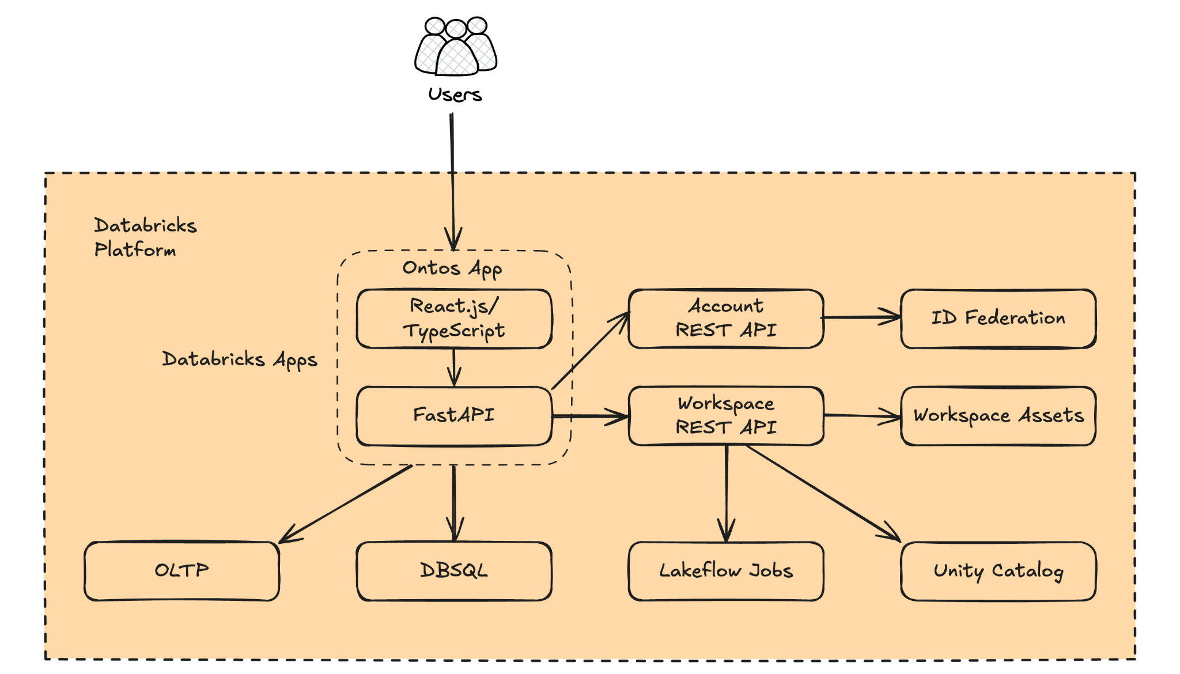
Ontos builds natively on the Databricks platform, making use of all available features suitable for its purpose. For example, it uses the following:
- Lakebase to store all the metadata it maintains, making the same available to the rest of the platform via our UC catalog support for Lakebase tables.
- Lakeflow Jobs to run all heavy lifting jobs, like table copying or compliance checking.
- Unity Catalog itself with Tag Policies to maintain tags and their assignment to data assets. This applies bidirectionally, as in either Ontos tags assets, or it scans the catalog for tagged assets and imports them into the app.
- Genie spaces build directly from Data Products, grouping assets together based on their status and version.
Ultimately, Ontos will drive consumption across the entire platform as it improves discovery via its Data Product-based marketplace and, therefore, increases data processing via many channels, and appropriate for all business users.

Why is it called Ontos?
While Ontos is covering more aspects of Data Governance, it is foremost aiming at better cataloging, discovery, and consumption. If you think about purchasing certain necessary items, you usually think about final products, not raw steel or even iron and carbon to make your own steel, but about a set of screws you need to build a cabinet, or an entire, already built cabinet. Products are aligned to where they are needed in the value chain, and have their own lineage connecting the screw to the hinge to the cabinet. Data-driven companies adopt this value chain thinking, defining products along the way. These products need lifecycle management and strict contracts between producers and consumers. On top they need to reflect the realm they implement. This means we have to overlay the product-thinking with business semantics, attaching meaning to each part of the value chain.
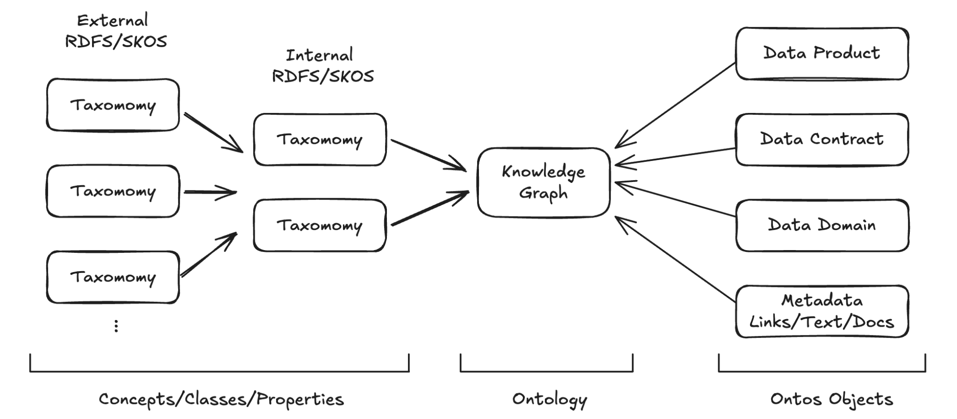
Ontos this by supporting the use of external taxonomies (maintained outside), and internal ones that encode the Databricks realm, as well as the Ontos specific one. This is all merged into a knowledge graph, representing the business ontology. Users can now use the graph to perform much more powerful searches, using inference with business semantics.
Ontos also supports a few other Data Governance related topics that support the overall usability. Think of an office building with workers performing business functions, while also having only a handful of facility staff that keeps the building in operations. Some of the recurring janitorial tasks are integrated into Ontos allowing a handful of dedicated personnel to set up security and managed multi-site metadata exchange. As with the diagram above, this metadata is added to the knowledge graph, allowing stewards to review which personas are assigned to data products, based on semantics.

Do all customers need to build an ontology now?
Yes and no - on the one hand, that would greatly improve the discoverability and reusability of data by both people and agents. On the other hand, it is a big investment of time and effort to build and maintain such a resource and that may be too much for many customers.
We should therefore simplify this in three ways: gradual implementation, enabling reuse of existing ontologies and automation.
From the perspective of gradual implementation, we define a hierarchy of expressivity, starting with a humble business glossary and growing up to a full ontology.
Business Glossary/Controlled Vocabulary | A set of terms with defined meaning in the domain of interest that identify particular concepts. This may or may not include synonyms at this stage.
Taxonomy | A hierarchy of controlled vocabulary terms that relates broader and narrower concepts. This will also include synonyms, enabling linkage of different taxonomies.
Ontology | A taxonomy that also includes definitions of relationships that can exist between the concepts.
Knowledge Graph | Data structured as a graph together with an ontology that defines the meaning of the concepts and relationships.

These artefacts traditionally live in isolation, maintained outside a data platform. One of the key features of Ontos is “semantic assignment”, making it simple to map a concept to the data that represents that concept.
Customers may be lucky enough to operate in an industry where a comprehensive standard ontology exists (e.g. FIBO for FSI, or any one of a wide range of ontologies for HLS). Since Ontos is built around the open and widely accepted RDF family of standards they can import such an ontology and immediately start using it as a basis to define the semantics of their data.
Alternatively, they may want to define their own set of concepts and relationships, and this should be an easy process. Tools like Palantir’s Foundry provide a very clean experience for this, albeit in a closed-source manner.
Finally, the metadata available in Unity Catalog provides the opportunity to automate much of the creation and maintenance process, potentially even using an Agentic approach. For example, the user is provided suggestions on concepts to attach to a particular securable based on the lineage or analysis of how the data is being used.
This combination of existing Databricks features with the additional capabilities provided by Ontos makes it practical to maintain an ontology close to the data in a way that has historically not been possible.

Graduation Strategy
Databricks Apps is our path for n-fold growth, akin to when Oracle started offering vertical solutions on top of their RDBMS offerings. Our own platform cannot and should not add all the special features required for such vertical solutions (like loading arbitrary ontologies into the control plane), but should instead rely on apps to add such features, deeply embedded in the platform using all available building blocks, such as APIs, Lakebase, and DBSQL, Lakeflow, Tag Policies, and so on. Ontos does this for data management and semantic modelling. It will become a fully featured application that enables business users to manage their data assets in a domain-oriented manner. While we expect some features to be reintroduced to the platform, many can remain in the app permanently.
- You are motivated to keep the project healthy in the long term. See http://go/labs/healthy for more details. ✅
- At least one of the engineering teams could potentially take over this project into the main product ✅¹
- At least one of the Product Managers supports the idea of this project ✅
- Labs guide and PM sign off on requirements and proposal
¹ It is explicitly wanted for Ontos to also act as a test bed for new features that potentially are added into the platform natively over time.

Project kickoff
- Add your doc to the projects folder.
- Submit this doc to labs@databricks.com.

Administrative actions
These actions are performed by your Labs guide. Find one after PM and engineering counterparts sign off on the proposal. SLA is 2 weeks.
- Request labs-oss@databricks.com to create a repository in https://github.com/databrickslabs for the project.
- Request labs-oss@databricks.com to enable LABS_PYPI_TOKEN for a new repository.
- The project has a GitHub team added https://github.com/orgs/databrickslabs/teams
- Collaborators and teams: GitHub team has the Maintain rights on the project repository
- Collaborators and teams: Owner of the project has the ability to add more people to the project team
- Branches: The main branch has a protection rule
- Branches: The main branch requires a pull request before merging
- Branches: Restrict who can push to the main branch: Organization administrators, repository administrators, and users with the Maintain role (default)
- Tags: There’s tag protection rule for v*.
- Actions / General: Require PR approval for first-time contributors

Part 2: Design sketch
[Instructions]
- Labs reviewer and PM sign off on requirements and proposal
- Submit an SDR ticket for mandatory security and other reviews
- Required stakeholders sign-off on Design sketch

Many customers find Critical User Journey (CUJ) XYZ confusing, which limits its adoption (e.g., cited as a major pain point by customers A, B, C). This design reduces the steps to accomplish CUJ X by 50%, which we believe will improve the adoption of feature Y by 25%. See the Appendix for analysis.

[Instructions, you can use https://mermaid.live/ and markdown integration in GitHub to version control the diagrams, you can also use https://excalidraw.com/ to make lo-fi diagrams to copy into these documents]
We want to introduce a component to My System to support use cases A, B, and C.

[Optional] Major alternatives
[Instructions]

Alternative: Use an OSS solution like DataHub, or a commercial one like Collibra, Alation, Atlan etc.
While these products can handle similar functionality to some degree, none are as deeply embedded and as native as Ontos is. More specifically, all 3rd Party solutions (OSS or commercial) have little interest in giving control back to our platform once the users start using their own UI. It is common for these tools to mostly extract metadata into their service and then take over. It is hard to impossible to feed back defined business semantics from these tools so that other use-cases can benefit. Other tools aim at all incumbent services in a heterogeneous IT stack. Ontos does not need to do that as it ONLY runs inside Databricks. In addition, Ontos drives native $DBU consumption, while other SaaS offerings offload compute to their account as much as possible. Finally, Ontos serves as a Petri dish for our own PM to see what customers need in the platform, driving innovation and improvements directly.
One example of a partner who is touching on this concept is Kobai, however their product focuses more on modelling the business and providing a Knowledge Graph over Databricks and less on the Data Product elements.

[Optional] Uncertainties and dependencies
[Instructions]
- Ontos relies on our platform to deliver on its promises, including Databricks Apps itself, but also Lakebase, Lakeflow, System Tables, and so on. If we cannot run Ontos reliably, we can fail. As evidence to the contrary, Kasal is running inside the platform (via the Marketplace) and has dozens of production users!
- For some functionality, we need a) existing APIs, and b) bulk operation support. For instance, Ontos lets users create Genie Spaces out of Data Products. The API to do so must exist. Or, Ontos writes and reads tags from Unity Catalog. An efficient, non-single record API call to operate in bulk is dearly needed at scale.

Project Tracking
How do you intend to track the usage of this project via our logfood telemetry?
Answer: Ontos runs as a Databricks App, which means it can benefit from the existing service telemetry and dashboards. API calls could carry app information, akin to what is done in UCX to capture API calls from the app. At least, many API calls or CPU usage consumed via Lakeflow Jobs are directly attributable to the app's service principal. The jobs and other resources can also be tagged to surface usage metrics.
Once the app is available in the Marketplace, further metrics are produced on downloads etc.
Notes
There are various methods to track the usage of a Databricks Labs Project and attribute it to a number of DBUs. One or more of these can be employed. The preferred order is:
- Library Import Tracking
- Spark Config Parameter Tracking
- REST API tracking

Method | Description | Limitations
Library Import | Whenever a library is imported from a package, that telemetry is tracked against the cluster it was imported on. | DLT clusters do not track this for some reason (investigating)  DBSQL clusters cannot import libraries
Spark Config | Spark Configs can be tracked when used on clusters | Cannot be set via spark.conf.set(). Rather, it can only be detected if set upon cluster creation.  Cannot contain anything that is considered PII, like table name. Value is unable to be redacted.
REST API | Whenever a labs project is installed via the CLI, it’s name is included in the http_user_agent in the header. Other API calls to other Databricks endpoints can include the project name in the http_user_agent, along with other information, which can be detected. | Currently, the cluster_id is always redacted in the logs, which makes attributing labs projects to DBUs nearly impossible.  The lowest granularity therefore that can be attributed is to workspace.

Proposed Project Tracking
Track | Method | Description / Action Item | Action Taken
 | Library Import | Need to add library name to python_module_allowlist
 | Spark Config | Need to add spark config to spark config allowlist
 | REST API | Need to include project name in http_user_agent calls via the SDK method: databricks.sdk.config.with_user_agent_extra()

Part 3: Launch checklist

API Clients
[Please remove this section if the project is a library imported in a notebook]
- Unique user-agent string is designed for telemetry
- User-agent prefix is added to Labs ETL for telemetry

Python projects
[Please remove this section if the project is written in Java or Scala]
- There’s no project with a similar name on PyPI
- PyTest is used. See dbx or arcuate for examples.
- Setup.py has correct metadata. See arcuate for example.
- Style checks are enforced via black
- PyPI release is published
- PyPI release process is automated in CD, no manual release process is allowed
- Test coverage metrics are measured and presented publicly
- Reporting via codecov.io is required for http://go/labs/dash telemetry

Administration
[These actions are performed by Labs administrators]
- Dependabot is enabled
- (Python) LABS_PYPI_TOKEN added for this new repository
- Lgtm.io is integrated
- CodeQL checks are integrated
- GitHub URL is allow-listed in Universe to allow Git Folder access to the repo in the workspace. See Unblock my repofor more information.
  - Ontos Ticket: ES-1670724: Unblock repo for external customers - https://github.com/databrickslabs/ontos

Enablement
[Please add enablement materials and link them to this section]
- Enablement deck is ready
- Enablement video pitch is ready
- Schedule internal enablement session

Continuous integration
[Testing is fully automated]
- Github Actions are invoked for every pull request
- Code coverage is greater than 80%
- Codecov.io is integrated

Security & Legal
- Submit an SDR ticket for mandatory security and other reviews
  - SDR-3693: SDR for Project Ontos✅
    - AISEC-104: SDR for Project Ontos ✅
- Fill in http://go/designdoc/legal and submit LPP-XXX, follow up with legal-product@databricks.com
  - LPP-4515: Product Legal Intake Form ✅
  - LPP-4598: Review app for Labs ✅

Longevity
Projects cannot reach the v1.0 version since it’s a labs project. To reach v1.0 means to get production-grade support and to be included in the main product. Project must always be http://go/labs/healthy:
- Code review is complete
- The release process is documented. See the arcuate.
- The release branch is locked to prevent force-pushes
- Initial release starts with v0.0.1 or v0.1.0
- End-user documentation is available. See datagen for example

Marketing
- Blog request is submitted - http://go/blogprocess
- Marketing request is submitted to add it to https://databricks.com/learn/labs

